Lab - 1
Arduino Basics – Blink Inbuilt LED
1. Aim
To understand Arduino programming and verify board functionality by blinking the inbuilt LED.

2. Theory
Arduino Uno is an open-source microcontroller board based on ATmega328P. It has digital input/output pins used to interface with external devices.
The onboard LED (connected to pin 13) is used for testing. The blinking process demonstrates:
- Digital output control
- Program loop execution
- Use of delay timing

3. Apparatus / Requirements
- Arduino Uno
- USB cable
- Arduino IDE

4. Circuit Diagram
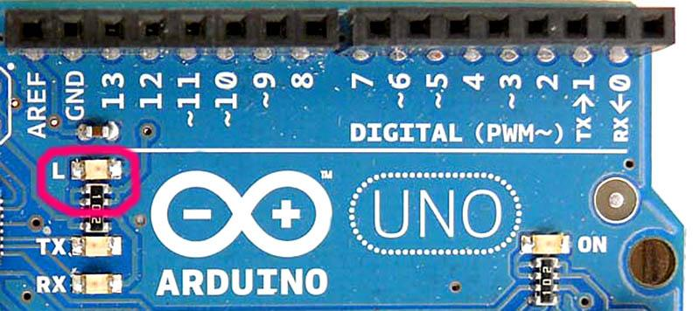
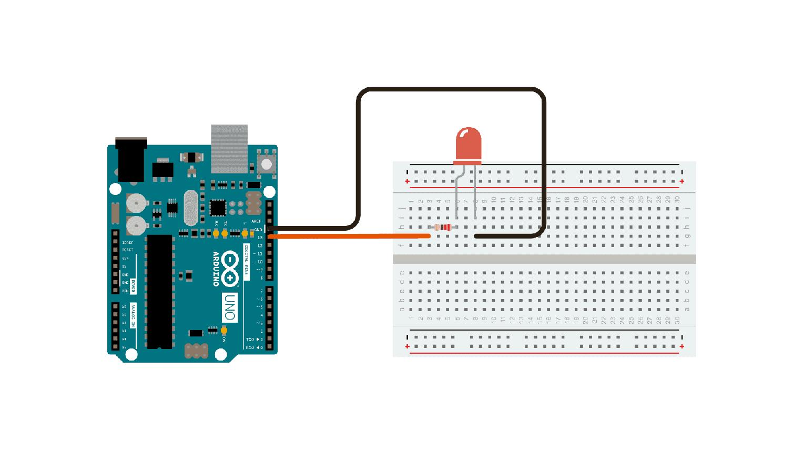
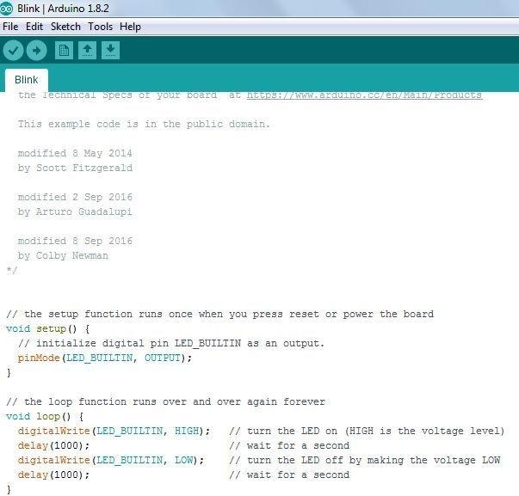
5. Procedure (Steps)
- Connect Arduino to computer using USB cable
- Open Arduino IDE
- Write the blink program
- Select board: Arduino Uno
- Select correct COM port
- Click Upload
- Observe LED blinking

6. Program / Code
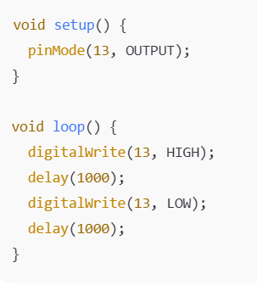

7.Observations / Readings
- LED ON for 1 second
- LED OFF for 1 second
- Continuous blinking cycle observed
- Confirms proper execution of program

8. Result
The onboard LED blinked successfully, confirming correct Arduino programming and hardware setup.

